socioeconomic_data

16 November 2018

The socioeconomic variables have been extracted from the Cambodian annual census known as the Commune Database. The commune database exists for the years 2005 - 2016 (excluding 2006 and 2013). One problem is that the number of questions (and therefore number of variables) in each census has changed over the years. Earlier censuses have fewer questions than later censuses, and some of the questions which exist across all censuses have changed slightly over the years. Another problem is that the number of villages and communes change over the years. Therefore care must be taken if we want to use census data from different years.

The raw data come at the village level, but because only point data exist for villages, I have aggregated the data up to the commune level, so that the data are spatially explicit. Below are the variables I have extracted (and cleaned and error checked) from the 2010 commune database:

|  |  |  |
| --- | --- | --- |
| Variable | Theme | Data class |
| Total population | Demographics | Discrete |
| Number of families | Demographics | Discrete |
| Males aged 18-60 | Demographics | Discrete |
| Females aged 18-60 | Demographics | Discrete |
| Population over 61 | Demographics | Discrete |
| Proportion indigenous | Demographics | Proportion |
| Males aged 6-24 in school | Education | Proportion |
| Females aged 6-24 in school | Education | Proportion |
| Males aged 18-60 who are illiterate | Education | Proportion |
| Females aged 18-60 who are illiterate | Education | Proportion |
| Families whose primary livelihood activity is farming | Employment | Discrete |
| Families whose primary livelihood activity is farming | Employment | Proportion |
| Families whose primary livelihood activity is fishing | Employment | Discrete |
| Families whose primary livelihood activity is NTFP | Employment | Discrete |
| Families whose primary livelihood activity is production | Employment | Proportion |
| Families whose primary livelihood activity is textiles | Employment | Proportion |
| Families whose primary livelihood activity is trading | Employment | Proportion |
| Families whose prim live. activity is service provision | Employment | Proportion |
| Families with less than 1ha of rice land | Economic security | Proportion |
| Families with no rice land | Economic security | Proportion |
| Families with less than 1ha of other farming land | Economic security | Proportion |
| Families with no other farming land | Economic security | Proportion |
| Families who have cattle | Economic security | Proportion |
| Families who have pigs | Economic security | Proportion |
| Distance to nearest school | Access to services | Continuous |
| Distance to nearest market | Access to services | Continuous |
| Distance to Commune office | Access to services | Continuous |
| Families with access to clean water | Access to services | Proportion |
| Families with access to piped water | Access to services | Proportion |
| Families with access to waste collection | Access to services | Proportion |
| Land conflicts in previous year | Social justice | Discrete |
| Criminal cases in previous year | Social justice | Discrete |
| Distance to nearest health centre | Health | Continuous |
| Infant mortailty per capita | Health | Discrete |
| Under 5 mortality | Health | Discrete |
| Number of in-migrants | Migration | Discrete |
| Number of out-migrants | Migration | Discrete |

Below are histograms for all of the variables, grouped by theme:

### Demographics

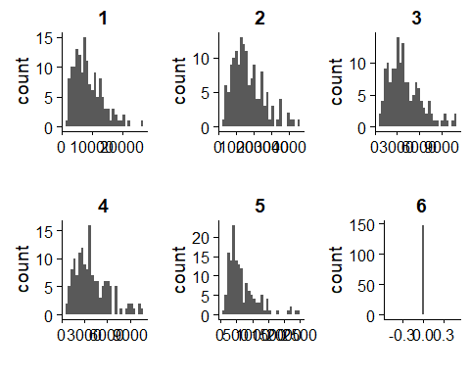

1 = total population, 2 = number of families, 3 = number of males aged 18-60, 4 = number of females aged 18-60, 5 = population over age 61, 6 = proportion of the population that are indigneous

### Education

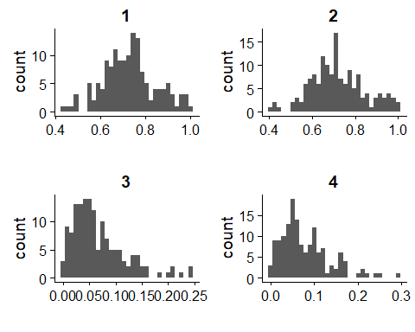

1 = proportion of males aged 6-24 in school, 2 = proportion of females aged 6-24 in school, 3 = proportion of males aged 18-60 who are illiterate, 4 = proportion of females aged 18-60 who are illiterate

### Employment

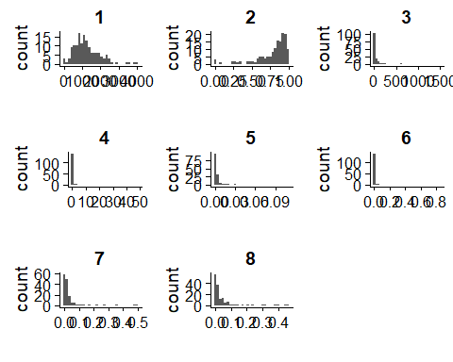

1 = number of families whose main livelihood activity is farming, 2 = proportion of families whose main livelihood activity is farming, 3 = number of families whose main livelihood activity is fishing, 4 = number of families whose main livelihood activity is NTFP, 5 = proportion of families whose main livelihood activity is production, 6 = proportion of families whose main livelihood activity is textiles, 7 = proportion of families whose main livelihood activity is trading, 8 = proportion of families whose main livelihood activity is service provision

### Economic security

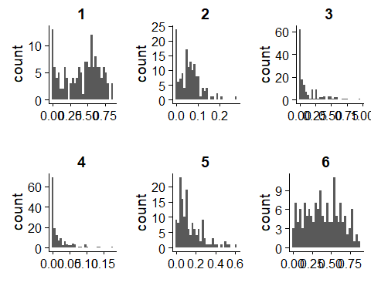

1 = proportion of families who have less than 1 ha of rice land, 2 = proportion of families who have no rice land, 3 = proportion of families who have less than 1 ha of other agricultural land, 4 = proportion of families who have no other agricultural land, 5 = proportion of families who have pigs, 6 = proportion of families who have cattle

### Access to services

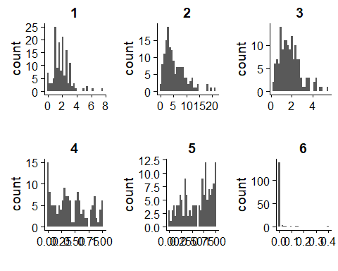

1 = distance to nearest school, 2 = distance to nearest market, 3 = distance to the Commune office, 4 = proportion of families who have access to safe water, 5 = roportion of families who have access to piped water, 6 = roportion of families who have access to waste collection

### Social justice

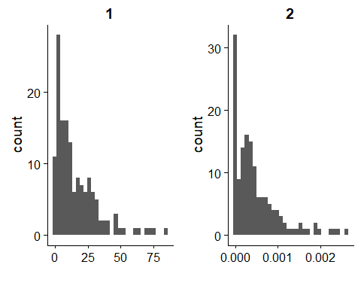

1 = number of land conflict per capita in the past year, 2 = number of criminal cases per capita in the past year

### Health

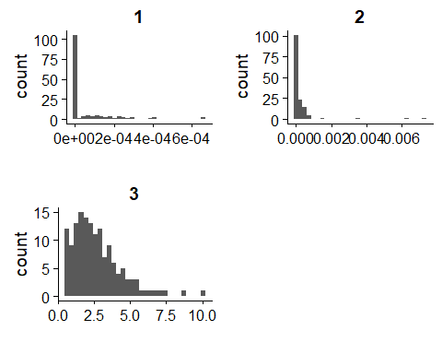

1 = number of infant deaths per capita in the past year, 2 = number of under-5 deaths per capita in the past year, 3 = distance to nearest health centre

### Migration

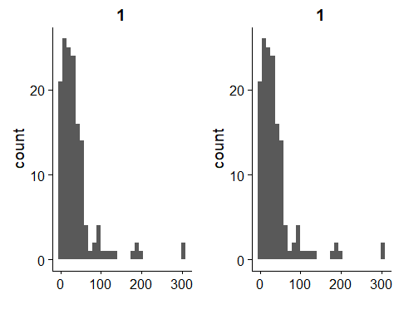

1 = number of in-migrants in past year, 2 = number of out-migrants in past year